Explanatory Document
Berry Heritage Planning Proposal (PP056) to amend Shoalhaven Local Environmental Plan (LEP) 2014

Affected Land
The twelve (12) proposed heritage listings and two (2) proposed Heritage Conservation Areas (HCAs) are located within the locality of Berry.
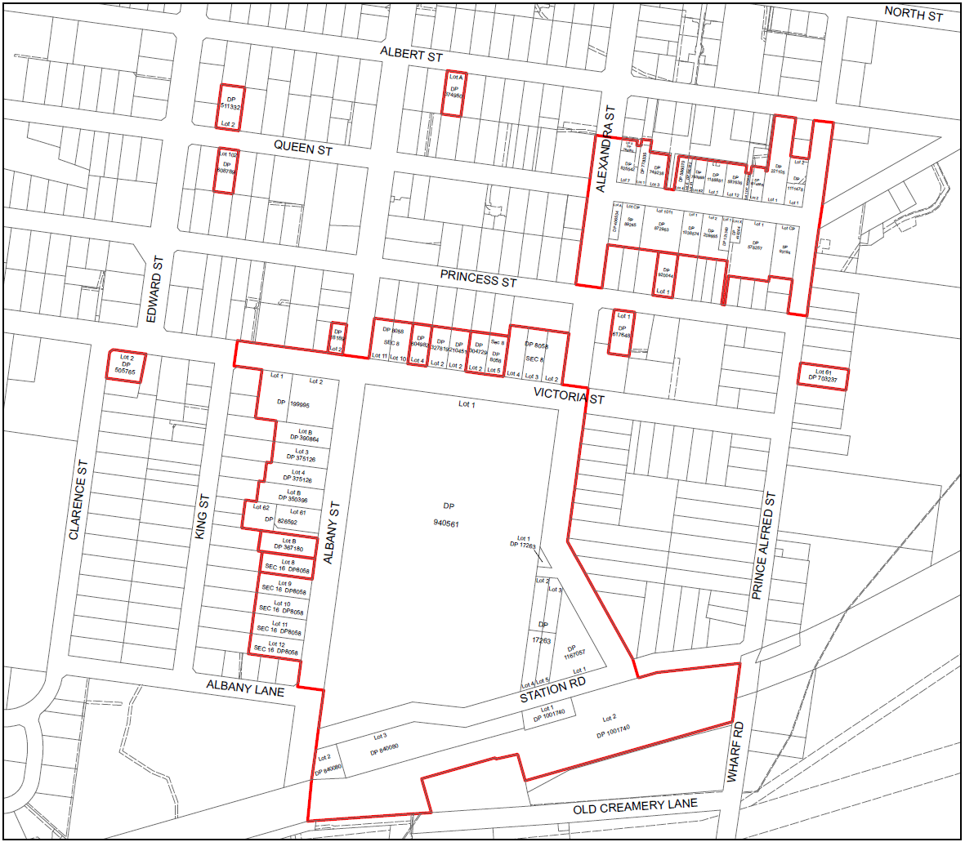
Figure 1: PP056 Subject Land
Refer to the Planning Proposal (PP) for further detail.

Overview
In response to community concerns that unsympathetic development was eroding the unique heritage character of Berry, Council commenced a heritage review of the town. A thorough review was undertaken and throughout the process, twelve (12) properties that were considered to possess heritage significance and two (2) HCAs were identified as worthy of inclusion in Schedule 5 of Shoalhaven Local Environmental Plan (LEP) 2014.

Background
Notable history of the Berry Heritage Planning Proposal (PP):
- A range of consultation has been conducted with a range of external stakeholders including community groups and property owners.
- On 1 September 2020, Council’s Development & Environment Committee resolved (MIN20.611) to:
  - Support an amendment to Schedule 5 of Shoalhaven LEP 2014 to list twelve dwellings (12) and two (2) HCAs.
  - Prepare and submit the Planning Proposal to the NSW Development of Planning, Industry & Environment for a Gateway Determination.
- A favourable Gateway Determination was received by Council on 22 March 2021.
- Condition 3 of the Gateway determination required consultation with Heritage NSW which has been undertaken. Heritage NSW’s response is at Attachment F of the PP, which provides support for the listings, subject to all required due diligence, assessments and notifications being completed prior to finalisation of the PP.

Proposed Changes
The following amendments are proposed to Schedule 5 of Shoalhaven LEP 2014:
- List the following twelve (12) properties in Berry as items of local heritage significance:
  - 27 Albany Street – Inter-War Federation Weatherboard Cottage.
  - 29 Albany Street – Inter-War Californian Cottage.
  - 46 Albert Street – Federation Weatherboard Cottage.
  - 36 Prince Alfred Street – Federation Weatherboard Cottage.
  - 64 Princess Street – Federation Weatherboard Cottage.
  - 71 Princess Street – Federation Weatherboard Cottage.
  - 51 Queen Street – Federation Weatherboard Cottage.
  - 54 Queen Street – Federation Weatherboard Cottage.
  - 44 Victoria Street – Federation Weatherboard Cottage.
  - 63 Victoria Street – Inter-War Weatherboard Cottage.
  - 69 Victoria Street – Federation Weatherboard Cottage.
  - 75-77 Victoria Street – Inter-War Californian Bungalow.
- List the following two (2) HCAs in Berry as HCAs of local heritage significance:
  - Queen Street Heritage Conservation Area.
  - Showground Heritage Conservation Area.
INTENT: To protect items and streetscapes that possess local heritage significance and assist in managing the character impacts on Berry by ensuring future development is sympathetic and recognises the heritage character of the area.
Refer to the PP for further detail.

Exhibition Documents
The Berry Heritage Planning Proposal is on public exhibition from Wednesday 19 May to Friday 18 June 2021 (inclusive) and available for viewing online at https://www.shoalhaven.nsw.gov.au/Council/Access-to-Information/Documents-on-Exhibition. Electronic copies of the exhibited package will be available at Council’s City Administration Centre (Bridge Road, Nowra) and at the Ulladulla Administration Building (Deering Street, Ulladulla) during business hours (9am-5pm) for the duration of the exhibition period.
The exhibition package includes:
- Explanatory Document
- Planning Proposal – Berry Heritage (PP056)
- Public Notice
- Gateway Determination (22/03/2021)

Request For Comment
Submissions relating to the Berry Heritage Planning Proposal are invited during the exhibition period and should be made in writing, and addressed to:
Post: The Chief Executive Officer, Shoalhaven City Council, PO Box 42, Nowra NSW 2541
E-mail: council@shoalhaven.nsw.gov.au
Website: via the form on the Exhibition page at:
https://www.shoalhaven.nsw.gov.au/Council/Access-to-Information/Documents-on-Exhibition
All submissions must be received in writing by 5pm Friday 18 June 2021, quoting Council’s reference 59450E.
Please note that correspondence submitted to Council on this matter may be open to public inspection without notifying the correspondents. Pre-printed form letters, which have been individually signed will be considered but not formally acknowledged. All persons who lodge a submission are required to declare any relevant political, donations and/or gifts in accordance with Section 10.4(5) of the Environmental Planning and Assessment Act 1979.
Enquiries should be directed to Emma Kell on (02) 4429 3213, quoting Council’s reference 59450E.

